PAC-Poly-Tahiti-Potatau-Omai Chiefs-Cook-1786

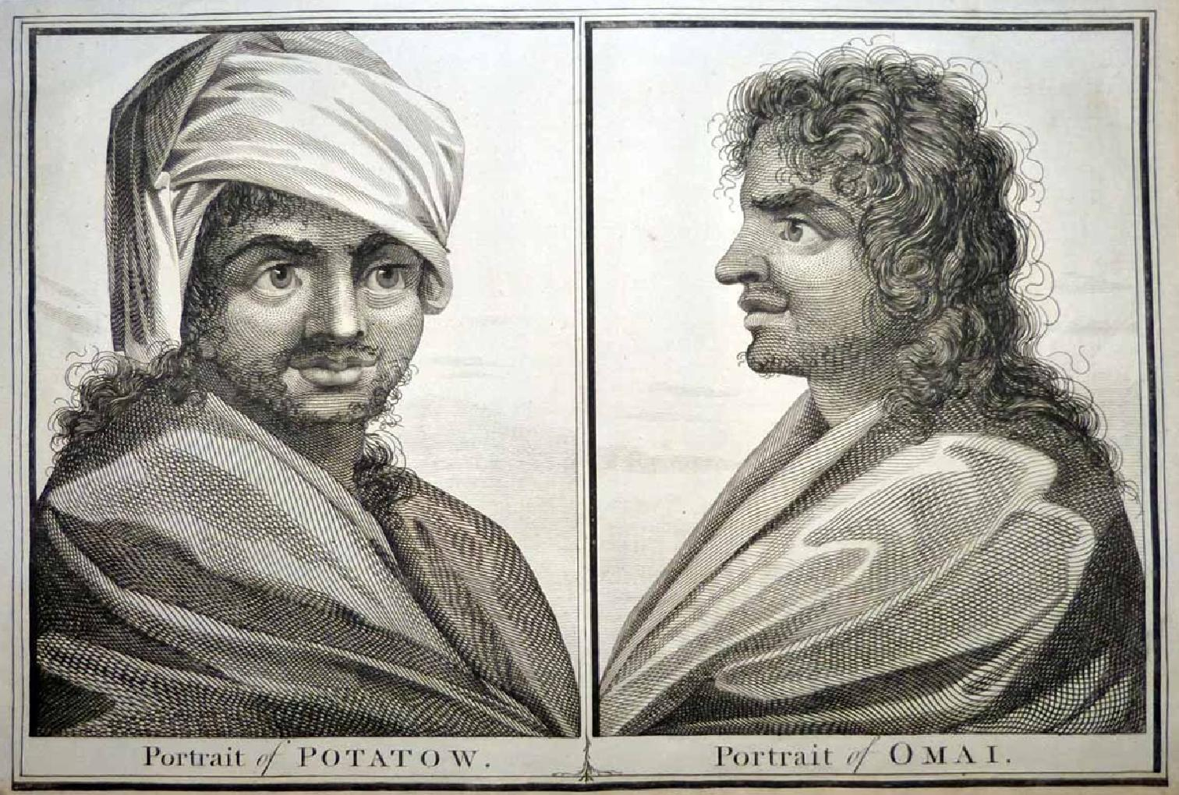

## Portrait of Potatow - Portrait of Omai

33.5 cm x 22.5 cm copperplate engraving, 38 cm x 24 cm sheet size, Alexander Hogg, London, 1786

We are pleased to offer this scarce original engraving from George William Anderson's account of "Captain Cook's First, Second, Third and Last Voyages" featuring two famous portraits related to Cook's voyages.  The first is that of the Tahitian Ari'i (Chieftain) of Punaauia known as Potatau drawn by [William Hodges](http://en.wikipedia.org/wiki/William_Hodges) in 1773 on Cook's Second Voyage.  After having traded some pigs for some brightly coloured red feathers, Potatau returned to offer Cook the services of his young wife in exchange for more feathers, an offer Cook declined.  The second, also attributed to Hodges, is of course that of the famous [Omai](http://www.captcook-ne.co.uk/ccne/themes/omai.htm) (1751-1780), a Ra'iatean who served as interpreter on Cook's second and third voyages and made a much heralded visit to Europe in 1774-1775.  A cultural phenomenon in England described as a "Noble Savage", Omai was also a key participant in Cook's explorations in his capacity as interpreter.  These twin portraits - rather stark and boldly engraved - will make an important addition to any collection related to Cook and the exploration of the South Pacific.  In addition, it will serve as a reminder of an important charitable contribution - ***100%*** of the proceeds from your purchase will be donated to [Médecins Sans Frontières](http://www.doctorswithoutborders.org/home.cfm) (Doctors Without Borders) whose important humanitarian work sadly remains in critical demand around the globe.

